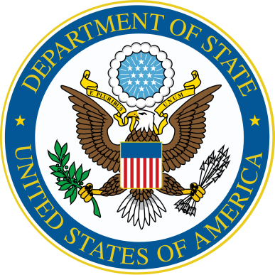
Benjamin Franklin

Transatlantic Fellowship 2019

Application Form

Please send your completed application to belarusprogram@state.gov no later than January 31, 2019

A. Last (family) name (as it appears in passport):

B. First name (as it appears in passport):

C. Middle name(s) if on passport:

D. Date of birth (month/day/year):

E. City of birth:

F. Country of birth:

G. Country of residence:

H. Country of citizenship:

I. Gender:

J. Full home address:

K. Home telephone number:

L. Cell phone number:

M. E-mail address:

N. Medical, physical, dietary, or other personal considerations
(at this time, no physical examination is required to participate in the program although the U.S. host institution may have specific requirements):

O. Name of the high school or college/university where you study:

P. Field of study (if applicable):

Q. Any other relevant educational, academic and professional experience or training:

R. Active memberships, special interests, or extracurricular activities:

S. Previous travel and study experience in the United States. Please include dates and indicate whether such travel was supported by U.S. government funds:

T. Please provide evidence of competence in written and oral English (e.g. test scores, teacher recommendations etc.):

U. Future study or career plans:

V. Written Essay (not to exceed 500 words): “Why Transatlantic Cooperation is Important to My Life and to the Future of Belarus”.

W. Please attach two recommendation letters from teachers regarding your academic achievements and leadership potential.

Please send your completed application to belarusprogram@state.gov
no later than January 31, 2019

